Year 9 Lessons to do at home: 16th March 2023

Lesson 1: English
Design a print-based advertising campaign for your new Health Drink (based on the product that you pitched yesterday) – see example below. It must contain 50-100 words and a full explanation of why this product is the best on the market. Recall and use a range of persuasive features in order to sell your product to the public.
For example …
Facts and statistics
Opinions
Rhetorical questions
Imagery
Emotive language
Anecdotes
Adjectives
Similes
Etc …

Lesson 2: Maths
Inflation has been in the news recently. But what is it?
Read through these slides – are you outraged about Freddos?
Inflation
Next you are going to learn about bank statements:
Watch the video and complete the questions.
https://corbettmaths.com/2022/01/06/bank-statements-video/
Worksheet
Answers

Lesson3: History
You have learned about the Spanish Civil war. This activity is a challenge to deepen your understanding of this conflict. Read through the PowerPoint and have a go at the worksheet.

Spanish Civil War.pptx
The-Spanish-Civil-War.docx

Lesson 4: Geography

Watch this clip about how rivers have changed and been changed by human activity.
Why rivers shouldn't look like this | It's Complicated
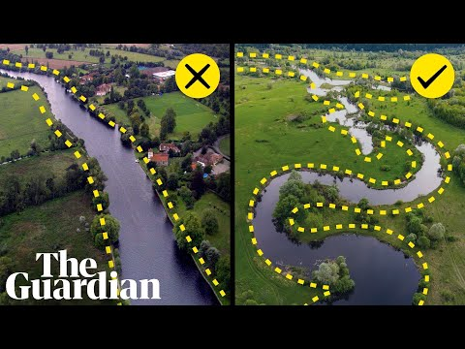

Create a summary page including information about:
- How rivers have changed
- Why rivers have changed
- What impact have these changes had.

Lesson 5: MFL

Either French or German:
French:
You are learning about foods from french speaking countries. Create a dialogue where a person or people are talking about food. This could be a conversation at home or in a restaurant. Use the link below to help you
https://www.bbc.co.uk/bitesize/topics/zjx947h/articles/z4xjrj6

German:
You are learning about jobs and the future. Use the powerpoint to complete the worksheet.
BERUFE-und-ARBEITSPL-TZE.pptx
JOBSgerman.docx

