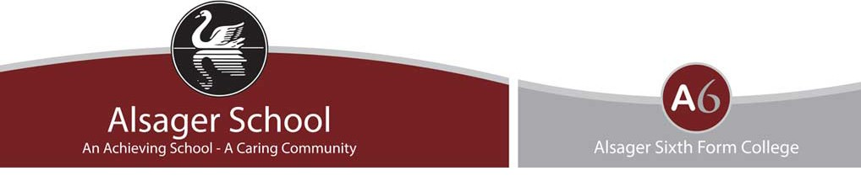

Frequently Asked Questions

How will grades be awarded this summer?

Grades for GCSEs, A levels, and vocational and technical qualifications including BTECs will be based on a rigorous process involving teacher assessment against national standards, internal quality assurance, and external quality assurance by the exam boards.

Alsager School will follow a process defined by the Department for Education and the exams’ regulator, Ofqual:
- Teachers will assess students against a national standard, using exam board materials including exam papers, mark schemes and standardisation resources.
- Grades submitted will be quality assured by the centre. The internal quality assurance process will be approved by the exam board to ensure it is rigorous and in line with national standards.
- External quality assurance will be carried out by the exam boards. This may include random sampling of our evidence.
- The exam boards will award students their final grades if they are confident in our submitted results.
- If students do not think their results are accurate, they have the right to appeal.

How will the loss of learning due to Covid-19 impact on results?

Due to the continued disruption of the pandemic, teachers will only assess students on content they have been taught. Students will not be disadvantaged if they have been unable to complete the full course however there must be a broad range of evidence to justify the grade awarded and sufficient coverage of the curriculum to enable progression.

What evidence will be used?

Teachers will draw on a range of assessment evidence from throughout the course, up until our internal deadline, Friday 28th May. Classwork, mock exams and papers set by the exam boards may contribute, with assessments completed towards the end of the course contributing more significantly. The exam boards are producing additional assessment materials that will be released before Easter. There is no requirement for any one type of assessment to be used – a range of evidence has been recommended by the Department for Education. Different departments may use different sources of evidence. To ensure the validity and reliability of the evidence, we have categorised work into strong, moderate and low levels of evidence. More information on this can be found on the ‘Teacher Assessed Grades Guidance for Parents’ PPT.

What happens if a student misses an assessment?

Students will be completing several assessments in each subject between now and the internal deadline of Friday 28th May. This is to provide students with plenty of opportunity to demonstrate the grade at which they are performing. If a student misses an assessment, they will be given the option of sitting it at another time. However, this is not necessary if there is a broad range of evidence from throughout the course to justify the awarding of a grade.

Will standards be different between different schools and colleges?

The standard against which teachers will be assessing students is set nationally by the exam boards. This is the standard that will be used during internal and external quality assurance and appeals to ensure consistency and fairness.

Am I entitled to my exam access arrangements when completing assessments in lessons?

Students who would usually have extra time, a reader, scribe or word processor in exams will still be entitled to these arrangements when completing an assessment in lesson. If, for some reason, a student has not been provided with what they are entitled to, they must inform their teacher.
Can parents and students lobby for a higher grade?

No. Teachers are using their professional expertise to assess students on the content they have been taught. The process for awarding GCSE and A Level grades is evidence-based, set against national standards provided by the exam boards. Any submission of grades without evidence would be considered exam malpractice. Any undue pressure by student or parent on teachers to increase grades will be referred to the exam boards and an investigation into malpractice may ensue. If malpractice is deemed to have taken place, this may result in the student’s certificate being removed.

How can students improve their grade between now and the internal deadline of Friday 28th May?
The Teacher Assessed Grade will be based on their continued performance, so this is what counts most. Students should continue to fully engage with their learning in lessons, act on feedback and complete independent revision. Ultimately, students have agency over their results.

